LOK SIN TONG YEUNG CHUNG MING PRIMARY SCHOOL
English Self Learning Worksheet ( PLPRWB – A Tale of Two Turtels )
Comprehension
Class: P.2 ( ) Date: __________________
Name: __________________ ( ) Grade: ________________

Look at the book cover. Choose the best answer by blackening the circle from Questions 1-4 and answer Question 5 in a complete sentence.
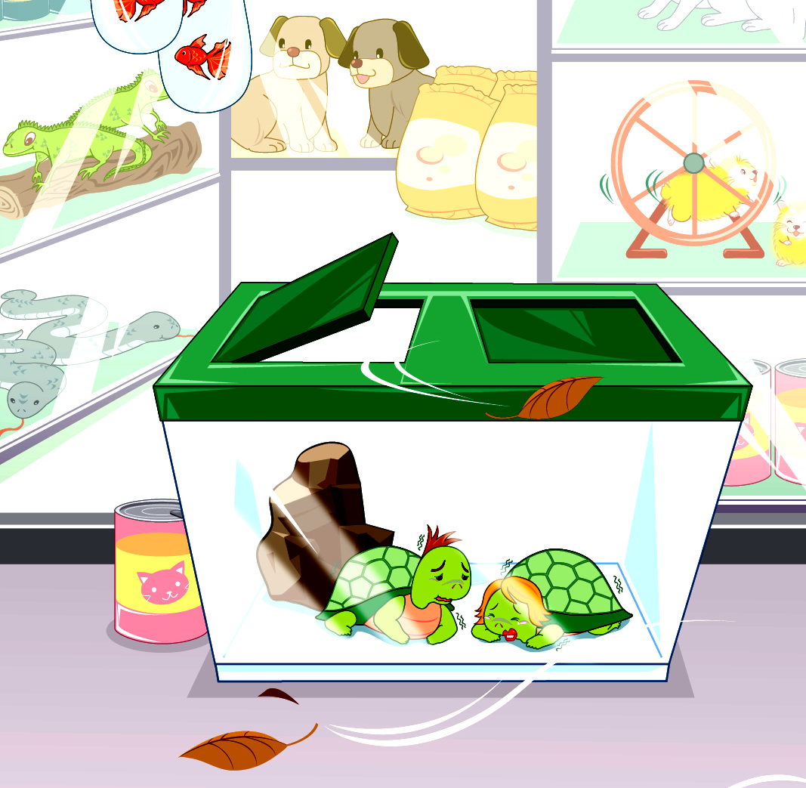

A Tale of Two Turtles

Author : Bob Chan
Illustrator : Sam Yip

- What is the title of the book?

OA. Bob Chan OB. Sam Yip

OC. A Tale of Two Turtles OD. Two Turtles

- ________ drew the pictures of the book.

OA. Bob Chan OB. Sam Yip

OC. The turtles OD. Bob and Sam

- ________ wrote the book.

OA. Bob Chan OB. Sam Yip

OC. The turtles OD. Bob and Sam

4. Where are the animals?

OA. in a pet shop OB. in a toy shop

OC. in the zoo OD. in the park

- How do the turtles feel?

____________________________________________________

